ME 315
THEORY OF MACHINES – DESIGN OF ELEMENTS
Fall 2024

Design Project
Group submission

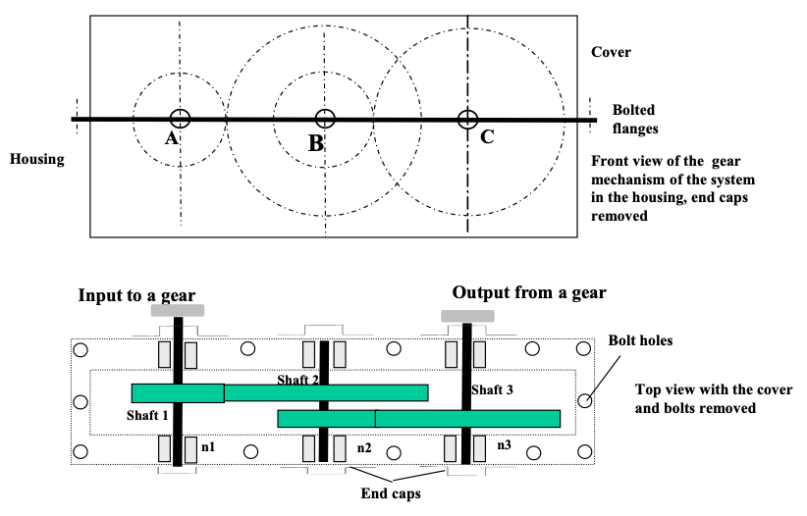

Group members
Danish Galebotswe Shaft system 1
Lochlan McGinnis Shaft system 2
Daniel Lechuga Shaft system 3

Grade
On-time step dues
Structural design, drawings /40
Design analysis /35
Report writing /20
Total________/95

Introduction
This design report presents the analysis and development of a three-shaft gear train system for transmitting power from an input shaft (Shaft A) to an output shaft (Shaft C) with a speed reduction. The system is designed to achieve the following key specifications:

- Power and Speed: The motor speed is 2700 rpm with a power input of 60 kW, and the output shaft speed (n₃) is to be maintained at 400 ± 3 rpm.
- Efficiency and Reliability: Assuming 100% efficiency for each gear pair and targeting a reliability of 99%, the design is expected to operate continuously for at least 5 years under the specified conditions.
- Structural Considerations: The design requires determining the optimal distance between shafts A and C, ensuring a minimum shaft diameter of 20 mm for stiffness, and considering fatigue stress concentration factors for bending and torsional stresses.

The report details the design process for each of the three shafts, focusing on achieving a compact, cost-effective, and efficient structure. Each team member is responsible for the design and analysis of one shaft, including gear, shaft, and bearing selections supported by detailed calculations. Additional components such as spacers, seals, and end caps are selected based on geometric design considerations.

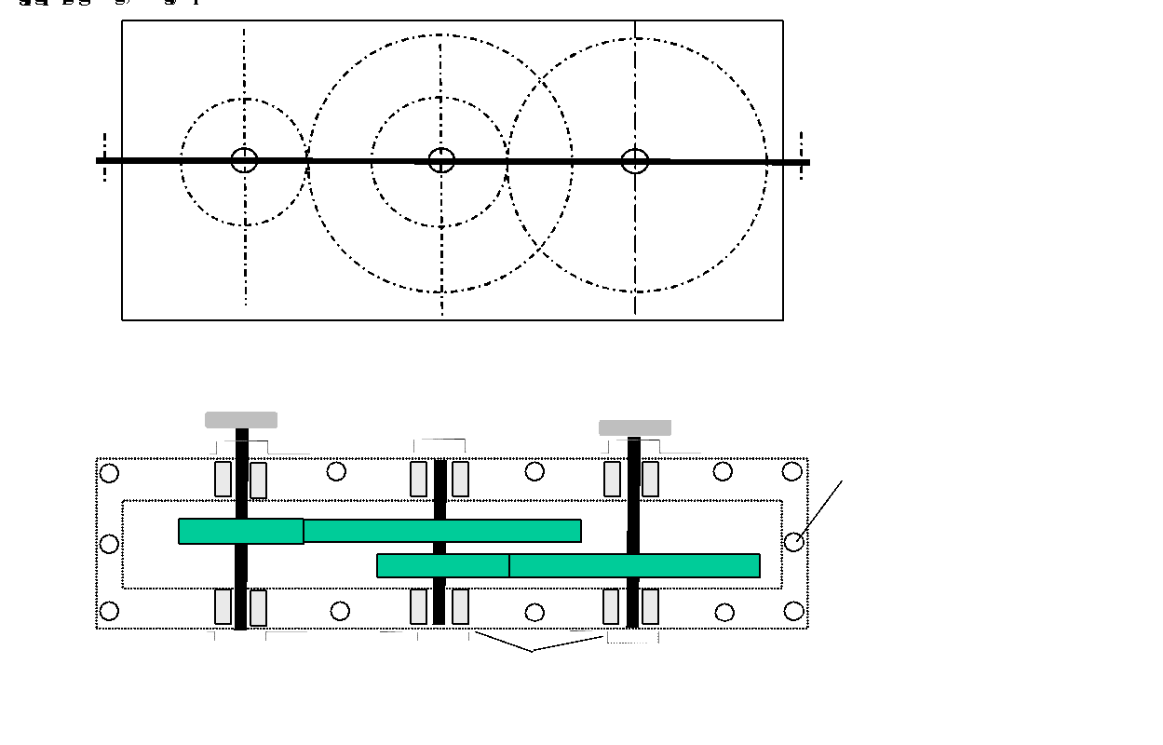
Figure 1: Schematic of the Transmission.

Scope of the Design
The scope includes the following aspects:

- Gear selection and arrangement (spur or helical gears).
- Force, geometry, and fatigue calculations necessary for shafts, bearings and gears.
- Compact layout of the gear train within a housing separated at the plane of shaft centerlines.
- Consideration of fits and tolerances for gear and bearing mountings.

Design Philosophy
While the housing design is not required, a rough housing design will be considered for conceptual convenience. The team aims to maximize performance and compactness while minimizing costs, guided by a structured approach to ensure durability and reliability in real-world operating conditions.

This report documents the decisions, methodologies, and calculations that underpin the design of the gear train system, demonstrating a robust and reliable solution for the power transmission application.

Gear Train and gear parameters
This section provides a comprehensive summary of the key parameters and design considerations for the three-shaft gear train system. The details include the power, speed, and geometry of each gear, as well as the forces, materials, and safety factors involved in the design. Additionally, the centerline distances between shafts and the total distance between Shafts A and C are specified.

The information is presented in Table 1, is structured to include:
- Power and speed (rpm) of each gear.
- Transmission error.
- Major geometric properties of the gears, including module, number of teeth, pressure angle, and face width.
- Centerline distances between shafts and the total centerline distance AC.
- Torque and gear forces.
- Material properties, hardness, and safety factors.
Note that: it is assumed that there is no power lost due to friction/sound/heat.
Table 1: Geartrain and Gear Parameters
Item | Gear 1 | Gear 2 | Gear 3 | Gear 4
Gear Type | Spur | Spur | Spur | Spur
Module (mm) | 5 | 5 | 5 | 5
Pressure angle (deg) | 20 | 20 | 20 | 20
Centerline Distance (mm) | 195 |  | 210
Total Centerline Distance (mm) | 405
Speed (rpm) | 2700 | 1060.71 | 1060.71 | 399.94
Resultant Transmission Error | $\frac{399.94-400}{400}=0.01\%$
Power (kW) | 60 | 60 | 60 | 60
Number of teeth (N) | 22 | 56 | 23 | 61
Addendum (mm) | 5 | 5 | 5 | 5
Dedendum (mm) | 6 | 6 | 6 | 6
Tooth height (mm) | 11 | 11 | 11 | 11
Clearance (mm) | 1 | 1 | 1 | 1
Circular Pitch (mm) | 16 | 16 | 16 | 16
Base Pitch (mm) | 15 | 15 | 15 | 15
Base width (mm) | 65 | 60 | 65 | 60
Tooth Thickness (mm) | 8 | 8 | 8 | 8
Pitch circle diameter (mm) | 110 | 280 | 115 | 305
Outside circle diameter (mm) | 120 | 290 | 125 | 315
Base circle diameter (mm) | 103 | 263 | 108 | 287
Root circle diameter (mm) | 97.5 | 267.5 | 102.5 | 292.5
Torque (Nm) | 212.21 | 540.16 | 540.16 | 1432.60
Wt (N) | 3858.30 | 3858.30 | 9394.13 | 9394.13
Wr (N) | 1404.31 | 1404.31 | 3419.18 | 3419.18
Material | AISI 4140 Steel, normalized, quenched, tempered | AISI 1045 Steel, Quenched and Tempered to 450 HB | AISI 4140 Steel, normalized, quenched, tempered | AISI 1045 Steel, Quenched and Tempered to 450 HB
Hardness | 578 | 450 | 578 | 450
Bending Factor of Safety | 5.85 | 4.56 | 2.45 | 2.17
Contact Factor of Safety | 2.04 | 1.55 | 1.43 | 1.15

This table summarizes the critical design outputs and serves as a quick reference for evaluating the performance and feasibility of the gear train. Detailed calculations supporting the values in the table are included in the Appendix for further reference and validation.

Shafts and Parameters
Table 2 provides a comprehensive overview of the design and operational parameters for shafts used in mechanical systems. The table includes key details such as the material properties, rotational speeds, maximum torque and bending moments, and the location of critical cross-sections. Additionally, it highlights the factors of safety applied, and whether the expected life of the shafts is considered infinite or finite. This information is critical for ensuring the shafts meet performance requirements under specified loading and operating conditions.

Material: AISI 1020 Steel, as rolled
Ultimate Tensile Strength: 420 MPa
Yield Strength: 350 MPa
Table 2: Shafts and Parameters
Item | Shaft 1 | Shaft 2 | Shaft 3
Speed (rpm) | 2700 | 1060.71 | 399.94
Maximum torque (Nm) | 212.21 | 540.16 | 1432.60
Maximum bending moment (Nm) | 127 | 235.04 | 377.69
Location of critical cross section | At Gear 1⁺  ($x=130.5 mm$)  Where torque is applied | At Gear 3⁺  ($x=58 mm$)  Where torque is applied | At Gear 4⁺  ($x=58 mm$)  Where torque is applied
Materials | AISI 1020 Steel, as rolled | AISI 1020 Steel, as rolled | AISI 1020 Steel, as rolled
Goodman Factor of Safety | 2.35 | 4.39 | 1.38
Yield Factor of Safety | 5.99 | 7.67 | 2.18
Expected Life | Infinite | Infinite | Infinite

Bearings and parameters
The bearing type selected is SKF Deep Groove Ball Bearings due to low friction and therefore being ideal for high speed application. Another reason for selecting deep groove ball bearings is due to the low thrust load through each shaft due to using spur gears (zero thrust load for all the bearings). Table 3 details the specifications and parameters of bearings used in the system, providing essential information for selection and performance evaluation. The table includes data on radial and thrust loads, bearing identification numbers, inner and outer diameters, widths, dynamic and static load ratings (C and Co), and the estimated service life for each bearing set. Additionally, it indicates whether bearing-change services are anticipated, ensuring clarity in maintenance and operational planning.

Table 3: Bearings and Parameters
Item | Shaft 1 |  | Shaft 2 |  | Shaft 3
Bearing: | Bearing A | Bearing B | Bearing C | Bearing D | Bearing E | Bearing
Radial Load (N) | 15583.36 | 46780.24 | 58477.01 | 79015.79 | 45864.43 | 52079.02
Thrust Load (N) | 0 | 0 | 0 | 0 | 0 | 0
Bearing Type | Deep Groove Ball Bearings | Deep Groove Ball Bearings | Deep Groove Ball Bearings | Deep Groove Ball Bearings | Deep Groove Ball Bearings | Deep Groove Ball Bearings
Bearing Numbers | SKF 6309 | SKF 6309 | SKF 6410 | SKF 6410 | SKF 6309 | SKF 6309
ID (mm) | 45 | 45 | 50 | 50 | 45 | 45
OD (mm) | 100 | 100 | 130 | 130 | 100 | 100
Width (mm) | 25 | 25 | 31 | 31 | 25 | 25
C (N) | 52,700 | 52,700 | 81,700 | 81,700 | 52,700 | 52,700
Co (N) | 31,500 | 31,500 | 52,000 | 52,000 | 31,500 | 31,500
Life (Mc) | 2358.72 | 2358.72 | 926.64 | 926.64 | 349.39 | 349.39
Bearing Change Service Needed? | No | No | No | No | No | No

Overall Results
Table 4: Overall Results
Item: | Value:
Power (kW) | 60
Input speed (rpm) | 2700
Output speed (rpm) | 399.94
Overall Design Factor of Safety | 1.15
Bearing Changes | The bearing life is calculated for 5 years, so no bearing change service is needed within this period. Maintenance operations should focus on monitoring for wear beyond the expected life.
Oil Changes | Oil changes are recommended annually to ensure proper lubrication and prevent wear or failure due to contamination. A felt seal is used to prevent oil leakage or debris ingress.
Additional Considerations | Bearings are standardized on the input and output shafts of the gearbox for ease of maintenance, reducing cost and assembly complexity. A bearing puller can easily remove bearings if required.

General Arrangement
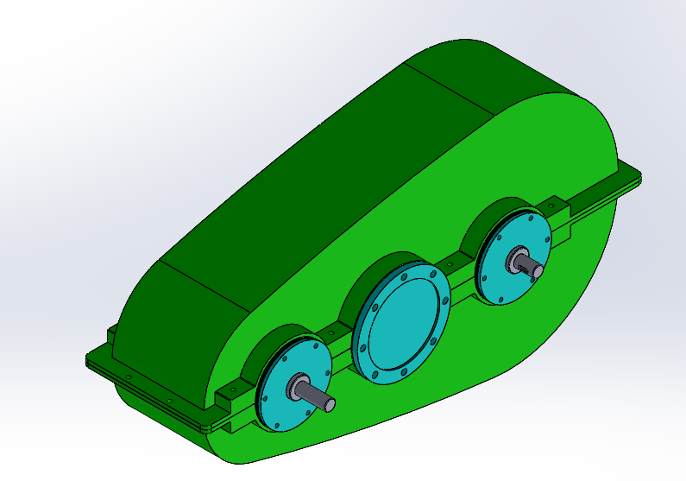
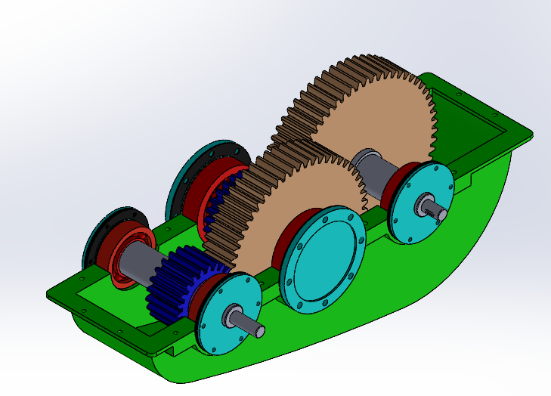

Shaft Assembly Drawings

Shaft 1 Assembly
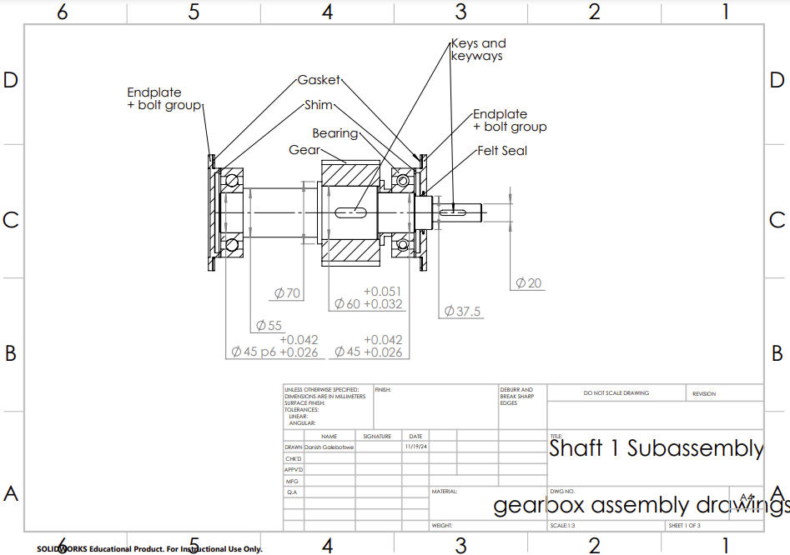

Shaft 2 Assembly
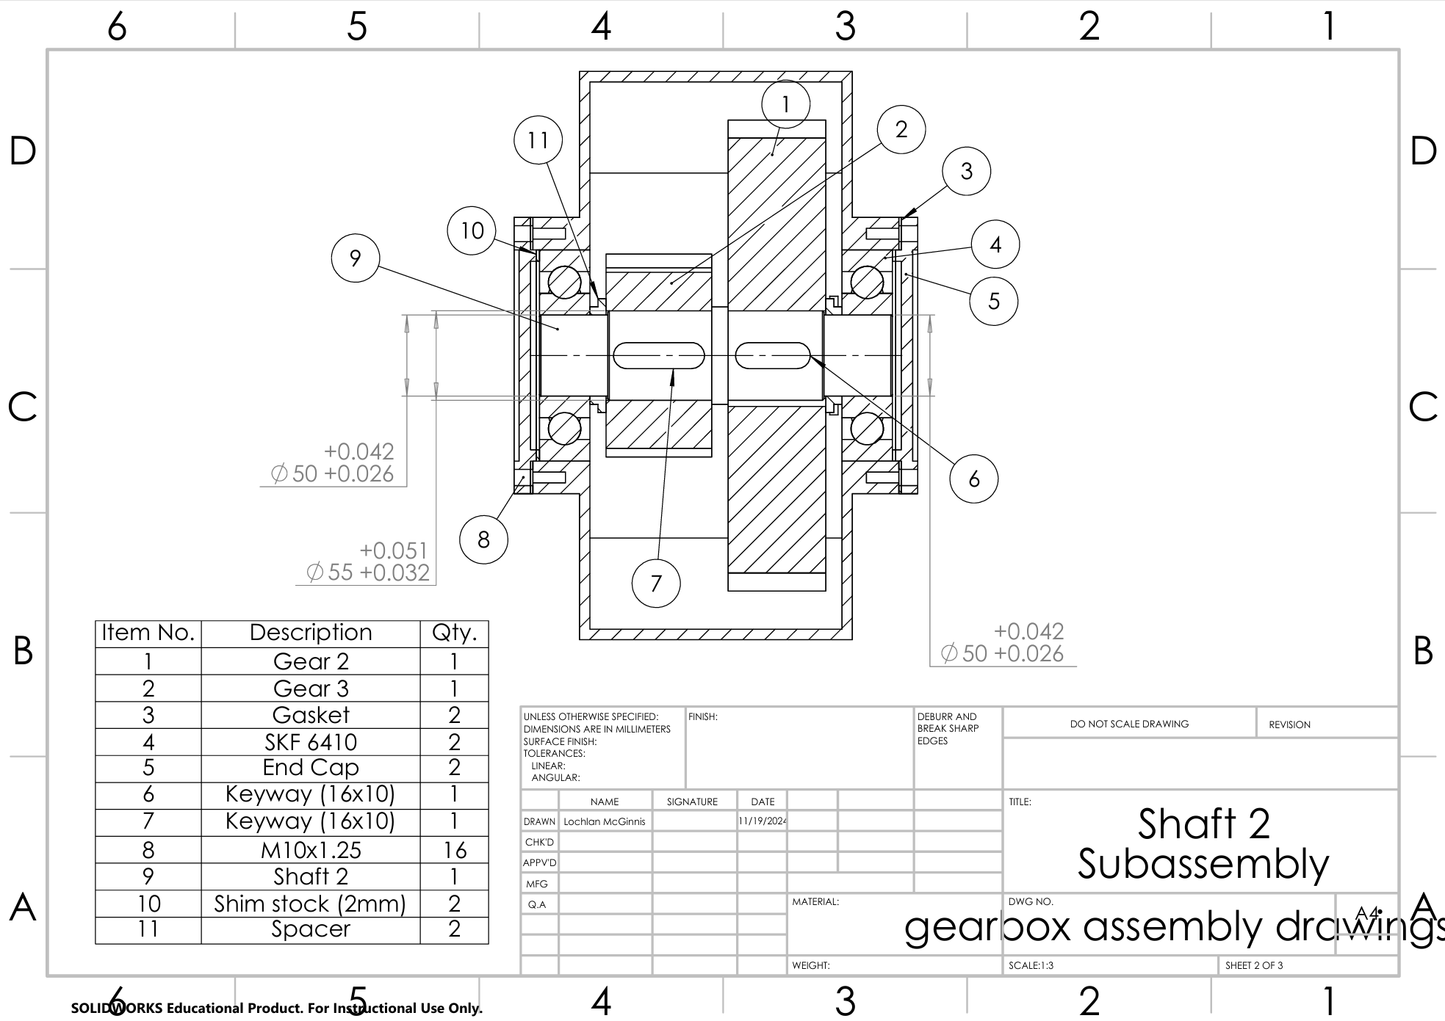

Shaft 3 Assembly
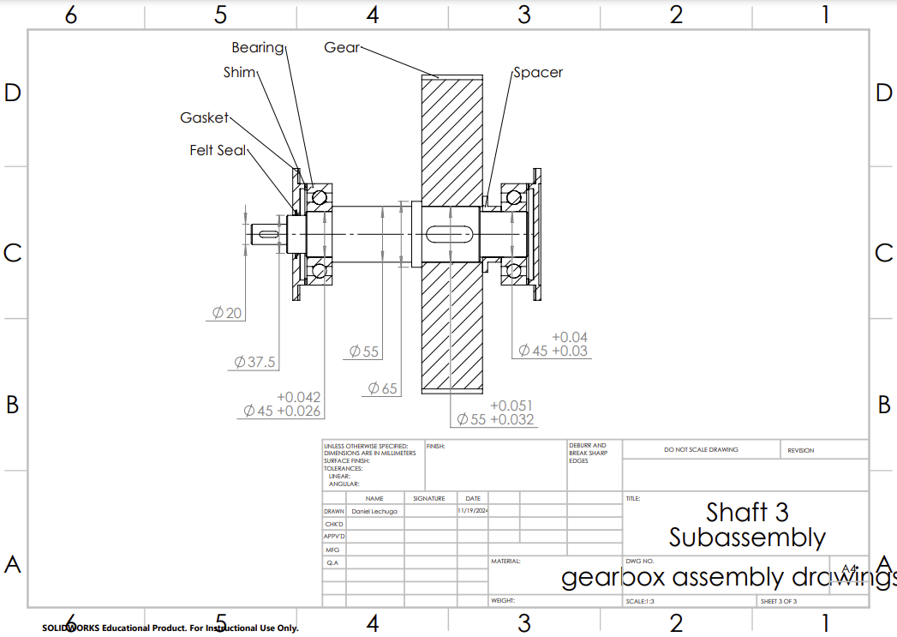

Shaft Part Drawings

Shaft 1
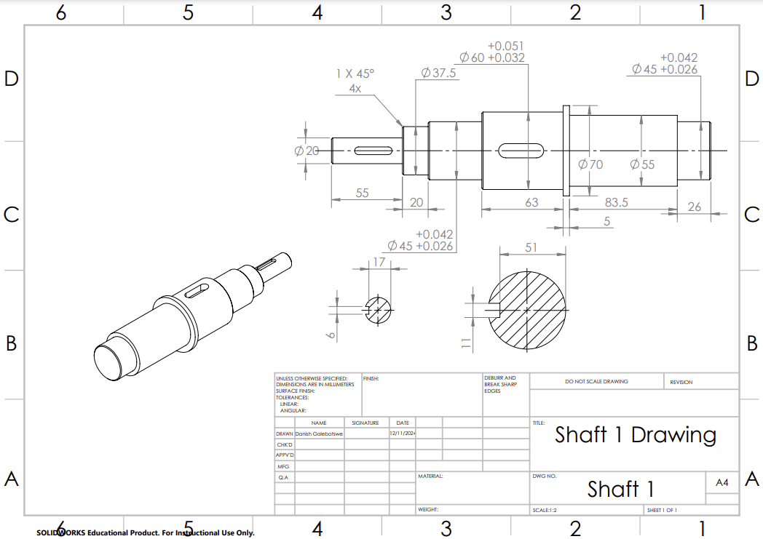

Shaft 2
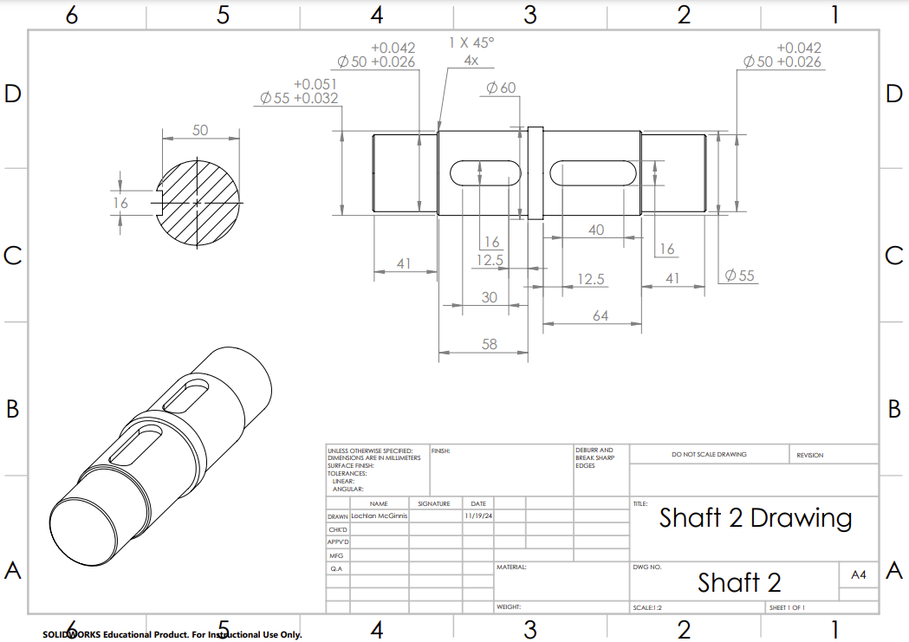

Shaft 3
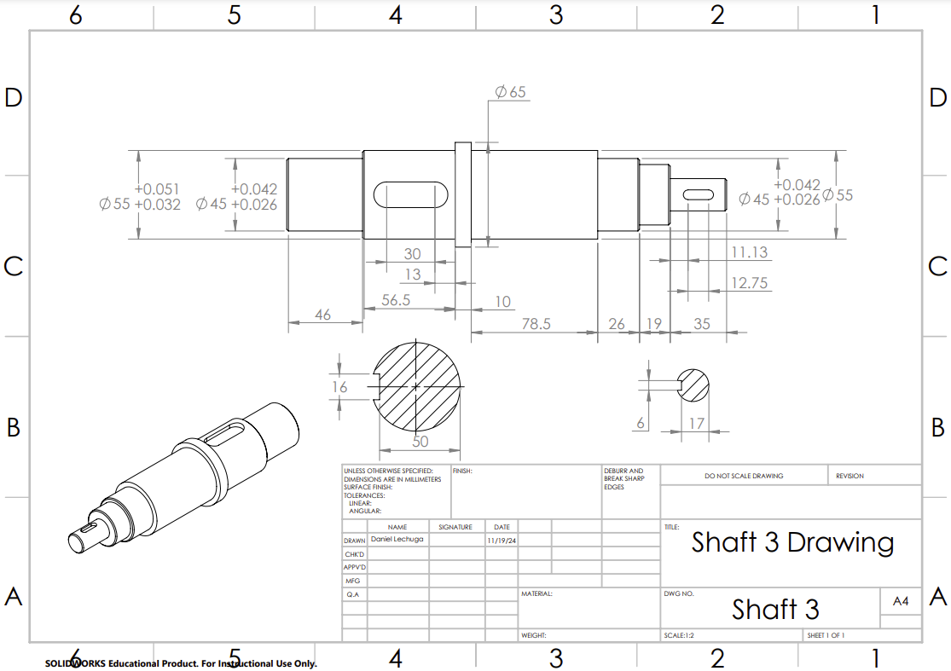

Gear Part Drawings

Gear 1
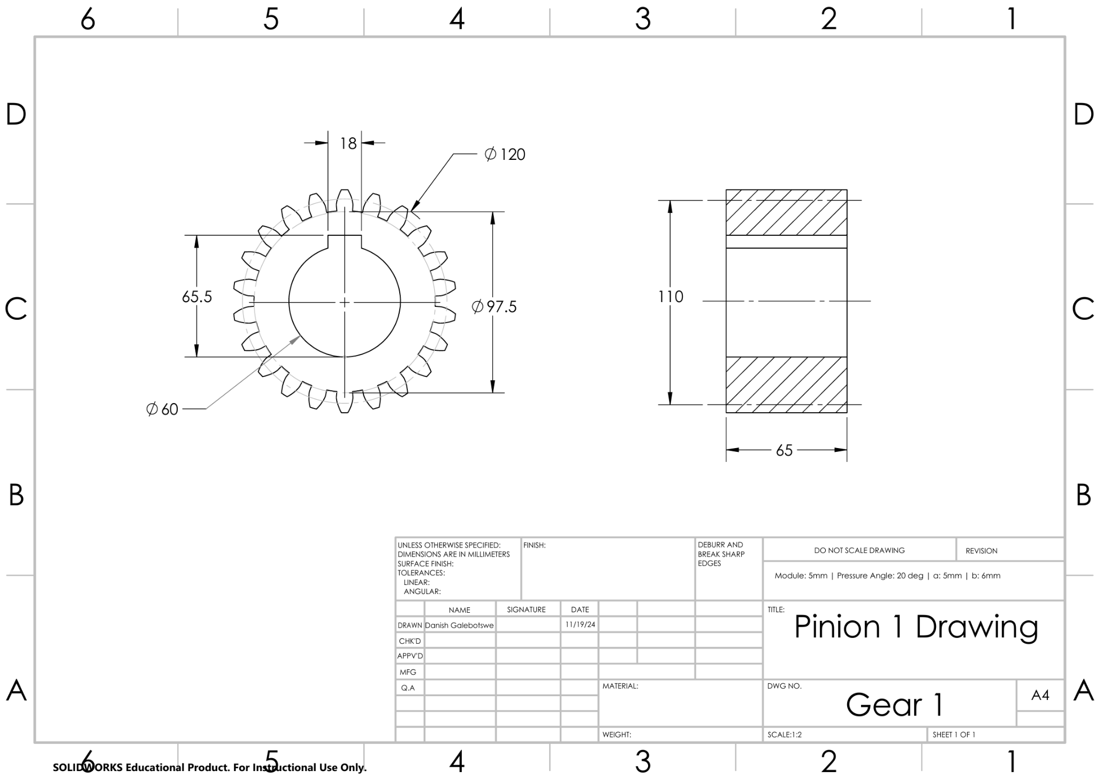

Gear 3

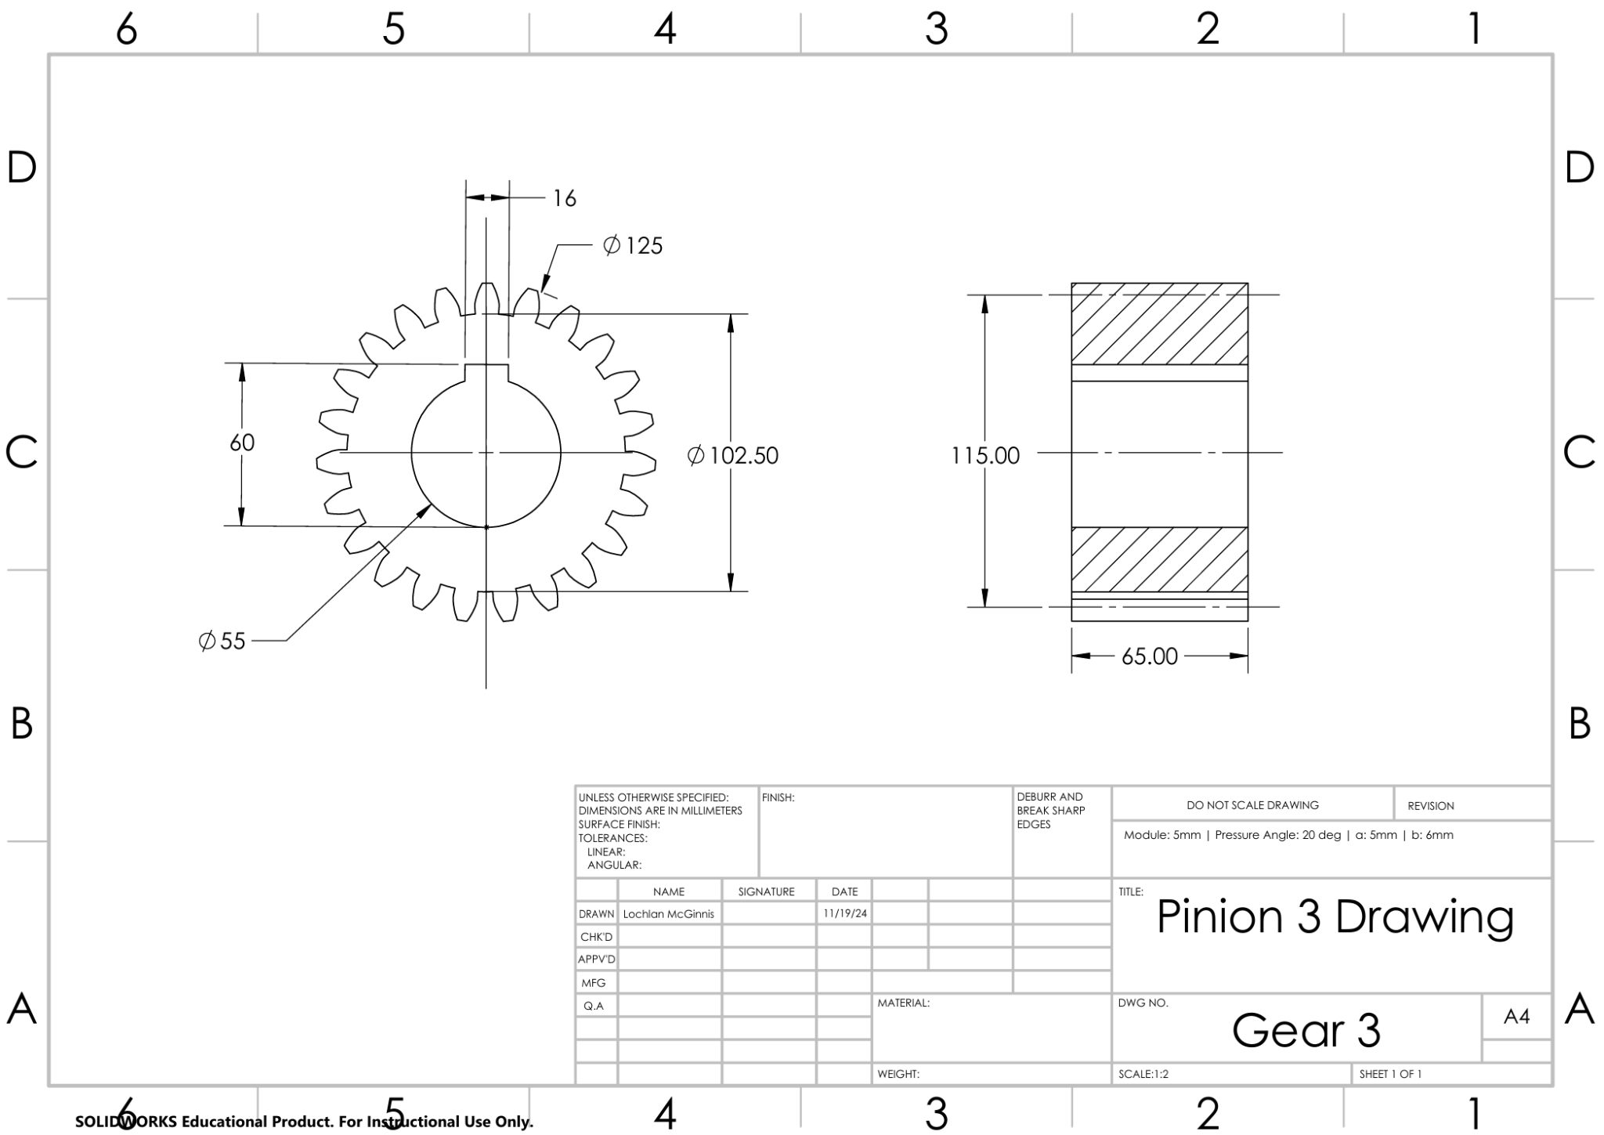

Gear 4

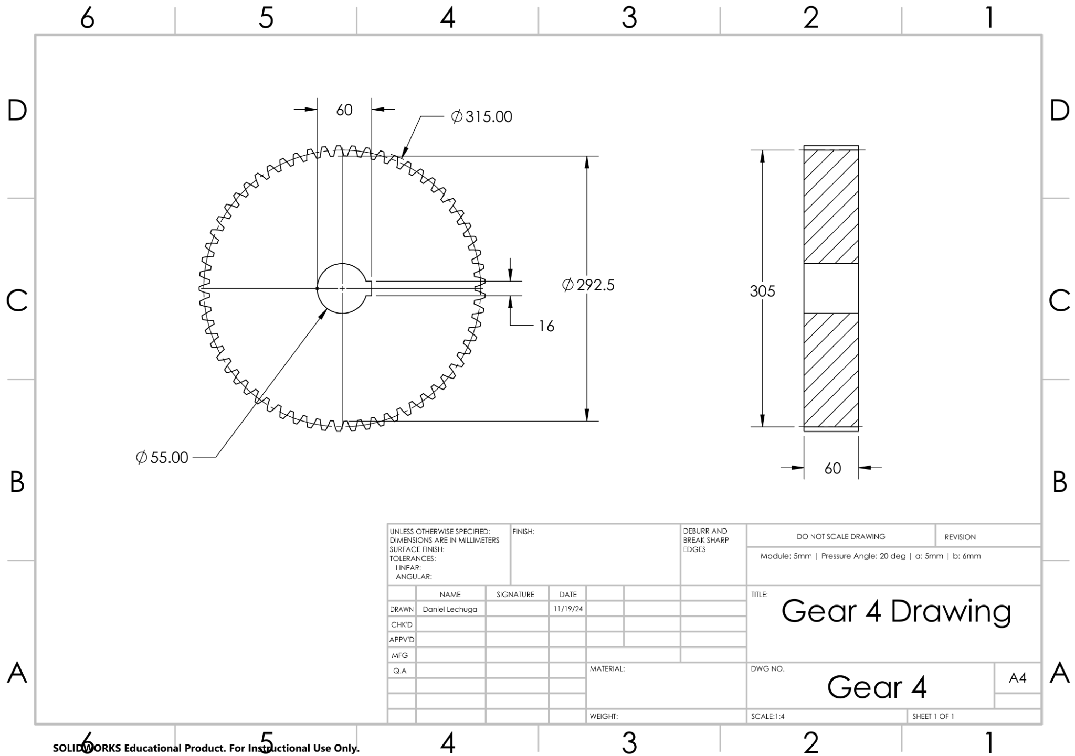

Appendix 1 - Shaft Analysis

Shaft System 1:
Key Parameters
Parameter | Symbol | Value | Unit
Speed | $n_{1}$ | 2700 | rpm
Input Power | $H$ | 60,000 | W
Number of Teeth | $N_{1}$ | 22 | -
Pitch Circle Diameter | $d_{p1}$ | 110 | mm
Pressure Angle | $ϕ$ | 20 | degrees

Equations and Calculations
- Torque:
$T_{1}=\frac{60H}{2πn_{1}}=\frac{60×60,000}{2π×2700}=212.21 Nm$
- Tangential Force:
$W_{t1}=\frac{{2T}_{1}}{d_{p1}}=\frac{212.21}{0.11}=3858 N$
- Radial Force:
$W_{r1}=W_{t1}tan\left(ϕ\right)=3858N*tan\left({20}^{∘}\right)=1404 N$
- Normal Force:
$W_{n1}=\frac{W_{t}}{cos\left(ϕ\right)}=\frac{3858N}{cos\left({20}^{∘}\right)}=4106 N$
- Velocity:
$V_{12}=\frac{πn_{1}d_{p1}}{60}=\frac{π×2700×0.11}{60}=15.6 m/s$
- Operation Hours:
$t=5 years×52 weeks/year×7 days/week×8 hours/day=14560 hours$
- Number of Cycles:
$N_{c1}=\frac{60⋅t⋅n_{1}}{{10}^{6}}=\frac{60×14560×2700}{{10}^{6}}=2358.72 Mc$
- Input Gear Parameters:
Pitch circle diameter: $d_{pi}=780 mm$
Tangential force: ${W^{t}}_{i}=\frac{T_{1}}{d_{pi}}=\frac{212.21 Nm}{200mm}=544 N$
Reaction Forces: $={W^{t}}_{i}tan(ϕ)=544 N ×tan(20 deg)=198 N$

Free Body Diagram and Bending Moments
- Shaft Parameters:
  - a = 58mm
  - b = 72.5mm
  - c = 55.5mm
  - d = 20mm
- Critical cross section: D⁻
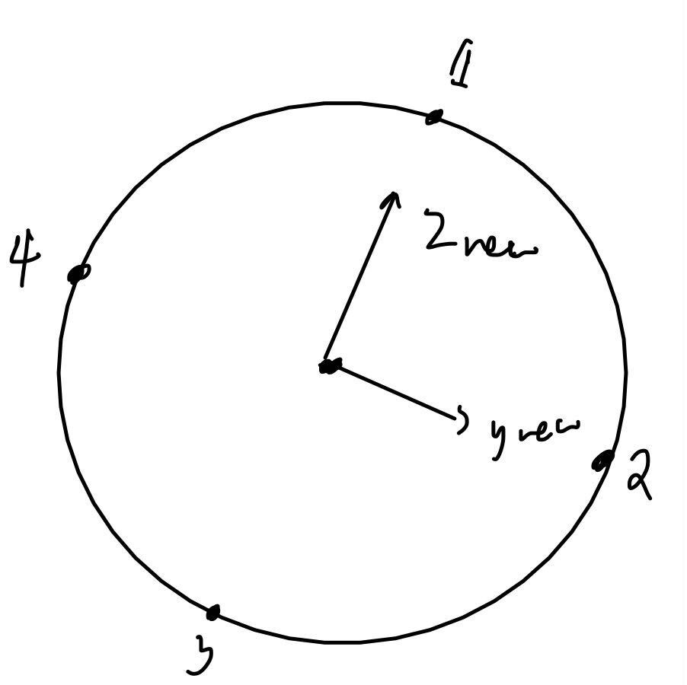
  - Diameter at D⁻: 50mm
  - Critical Point: 3

- Reaction Forces:
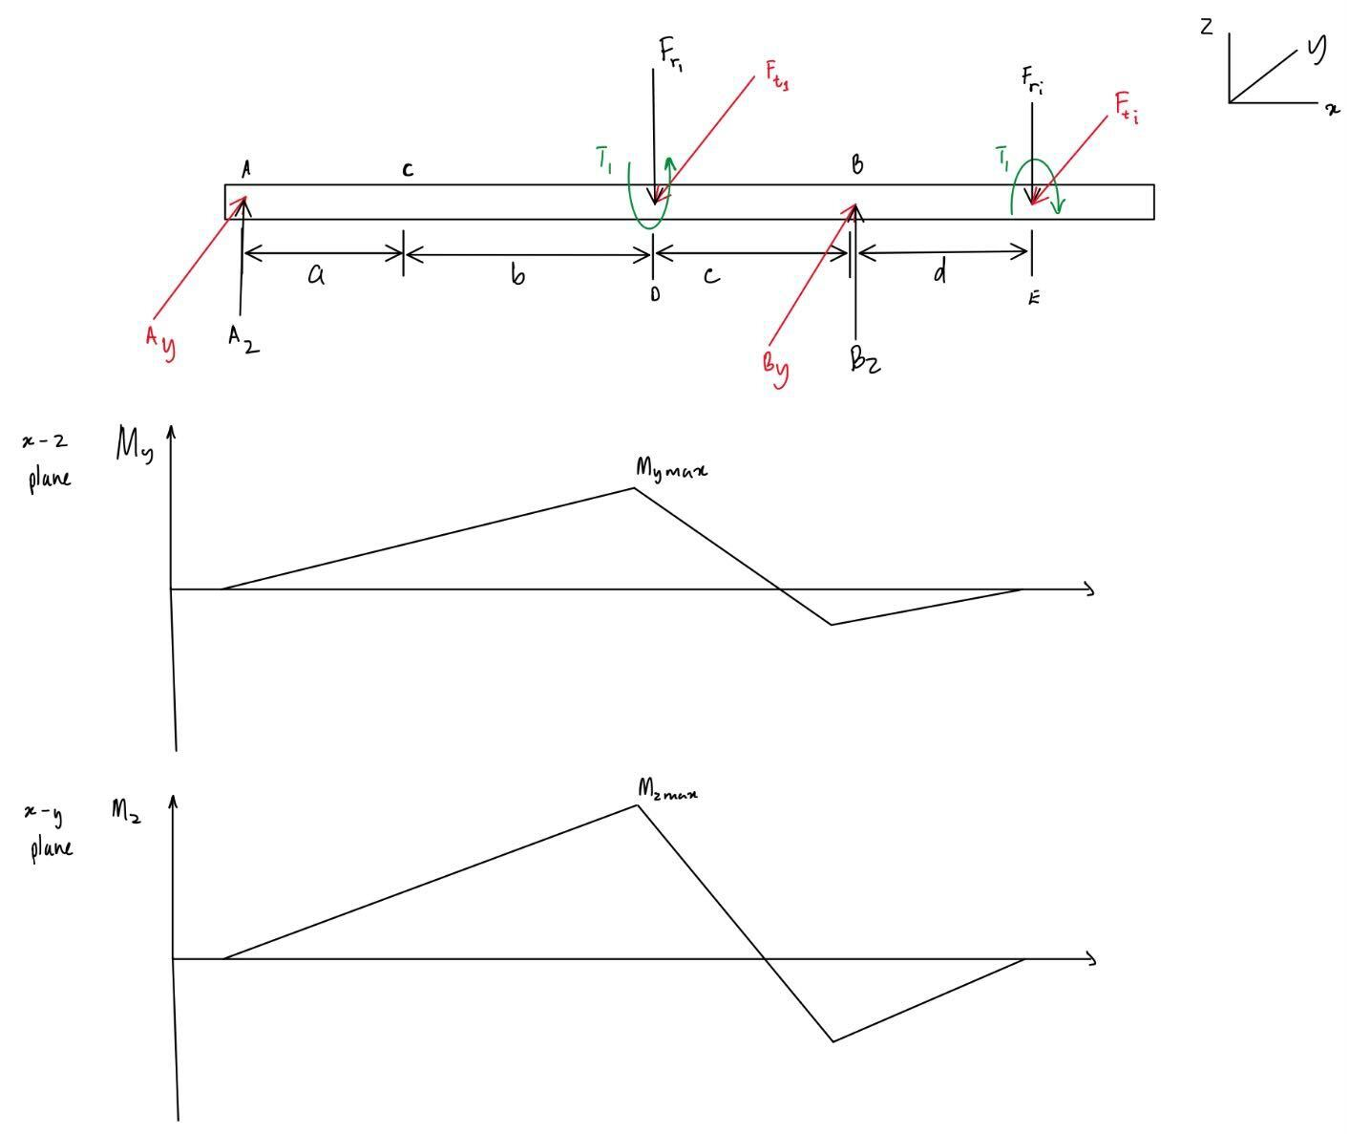

  - $ΣF_{y}=0:A_{y}+B_{y}-W_{t}-W_{i}=0$
  - $ΣF_{z}=0:A_{z}+B_{z}-W_{r}-W_{i}=0$
- Moments:
  - $ΣM_{y}=0\left(@A\right):B_{z}\left(a+b+c\right)-W_{r}\left(a+b\right)-W_{i}\left(a+b+c+d\right)=0$
  - $ΣM_{z}=0\left(@A\right):B_{y}\left(a+b+c\right)-W_{t}\left(a+b\right)-W_{i}\left(a+b+c+d\right)=0$
- Maximum Moments & Shear:
$M_{ymax}=A_{z}\left(a+b\right)=52 Nm$
$M_{zmax}=A_{y}\left(a+b\right)=144 Nm$
$M_{D^{-}}=\sqrt{M_{ymax}^{2}+M_{zmax}^{2}}=153 Nm$
$V_{D^{-}}=\sqrt{A_{y}^{2}+A_{z}^{2}}=1171 N$

Stress Analysis
- Transverse Shear Stress:
$τ_{V}=\frac{16V_{max}}{3πd_{cs}^{2}}=0.8 MPa$
- Torsional Shear Stress:
$τ_{T}=\frac{16T_{1}}{πd_{cs}^{3}}=8.6 MPa$
- Bending Stress:
$σ_{b}=\frac{32M_{max}}{πd_{cs}^{3}}=12.4 MPa$
- Von Mises Stresses: Where K_{f} = 1.5, and K_{fs} = 1.3
  - Alternating Von Mises Stress ($σ_{vm-a}$):
$σ_{vm-a}=\sqrt{{\left(K_{f}⋅σ_{b}\right)}^{2}+3{\left(K_{fs}⋅τ_{V}\right)}^{2}}=\sqrt{{\left(1.5⋅12.4\right)}^{2}+3{\left(1.3⋅8.6\right)}^{2}}=18.8 MPa$
  - Mean Von Mises Stress ($σ_{vm-m}$):
$σ_{vm-m}=\sqrt{3⋅τ_{T}^{2}}=\sqrt{3⋅{8.6}^{2}}=15.0 MPa$
  - Peak Von Mises Stress ($σ_{vm-peak}$):
$σ_{vm-peak}=\sqrt{σ_{b}^{2}+3{\left(τ_{T}+τ_{V}\right)}^{2}}=\sqrt{{12.4}^{2}+3{\left(8.6+0.8\right)}^{2}}=20.6 MPa$

Material Properties
The shaft material selected is AISI 1020 steel, with the following derived properties based on the design conditions:
- Ultimate Tensile Strength ($S_{ut}$):
$S_{ut}=450 MPa$
- Yield Strength ($S_{y}$):
$S_{y}=330 MPa$
- Endurance Limit ($S_{e}$): The true endurance limit is calculated using modifying factors:
$S_{e}=k_{f}k_{s}k_{r}k_{t}k_{m}S_{e}^{′}$
- Where:
  - $k_{f}$ = Stress concentration factor = $1.58{\left(S_{ut}/1000\right)}^{−0.085}=0.94$
  - $k_{s}$ = Size factor = $1.189{\left(1000d_{cs}\right)}^{−0.112}=0.76$
  - $k_{r}$ = Reliability factor = 0.82 (for 99% reliability)
  - $k_{t}$ = Temperature factor = 1 (ambient temperature)
  - $k_{m}$ = Miscellaneous factor = 1 (general use)
- Substituting values:
$S_{e}=0.94×0.80×0.82×1×1×450=133 MPa$

Factors of Safety
- Goodman Factor of Safety ($n_{s}$): The Goodman Factor of Safety is given by:
$n_{s}={\left(\frac{σ_{vm-a}}{S_{e}}+\frac{σ_{vm-m}}{S_{ut}}\right)}^{−1}={\left(\frac{18.8}{133}+\frac{15.0}{450}\right)}^{−1}=5.74$

- Yield Factor of Safety ($n_{y}$): The Yield Factor of Safety is given by:
$n_{y}=\frac{S_{y}}{σ_{vm-peak}}=\frac{330}{55}=16.10$

Shaft System 2:
Key Parameters
Parameter | Symbol | Value | Unit
Speed | $n_{2}=n_{3}$ | 1060.71 | rpm
Input Power | $H$ | 60,000 | W
Shaft 2 Torque | T₂ | 540.16 | Nm
Number of Teeth | $N_{2}$ | 56 | -
Number of Teeth | $N_{3}$ | 23 | -
Pitch Circle Diameter | $d_{p2}$ | 280 | mm
Pitch Circle Diameter | $d_{p3}$ | 115 | mm
Pressure Angle | $ϕ$ | 20 | degrees

Equations and Calculations
- Torque:
$T_{2}=T_{3}=\frac{60H}{2πn_{2}}=\frac{60×60,000}{2π×1060.71}=540.16 Nm$
- Tangential Force (Gear 2):
$W_{t2}=\frac{{2T}_{2}}{d_{p2}}=\frac{2×540.16}{0.280}=3858 N$
- Tangential Force (Gear 3):
$W_{t3}=\frac{{2T}_{3}}{d_{p3}}=\frac{2×540.16}{0.115}=9394 N$
- Radial Force (Gear 2):
$W_{r2}=W_{t2}tan\left(ϕ\right)=3858N*tan\left({20}^{∘}\right)=1404 N$
- Radial Force (Gear 3):
$W_{r3}=W_{t3}tan\left(ϕ\right)=9394N*tan\left({20}^{∘}\right)=3419 N$
- Normal Force (Gear 2):
$W_{n}=\frac{W_{t}}{cos\left(ϕ\right)}=\frac{3858N}{cos\left({20}^{∘}\right)}=4106 N$
- Normal Force (Gear 3):
$W_{n}=\frac{W_{t}}{cos\left(ϕ\right)}=\frac{9394N}{cos\left({20}^{∘}\right)}=9997 N$

- Velocity (Gear 2):
$V_{12}=\frac{πn_{2}d_{p2}}{60}=\frac{π×1060.71×0.280}{60}=15.6 m/s$
- Velocity (Gear 3):
$V_{34}=\frac{πn_{3}d_{p3}}{60}=\frac{π×1060.71×0.115}{60}=6.39 m/s$
- Operation Hours:
$t=5 years×52 weeks/year×7 days/week×8 hours/day=14560 hours$
- Number of Cycles:
$N_{c2}=N_{c3}=\frac{60⋅t⋅n_{2}}{{10}^{6}}=\frac{60×14560×1060.71}{{10}^{6}}=926.64 Mc$

Free Body Diagram and Bending Moments
- Diagram:
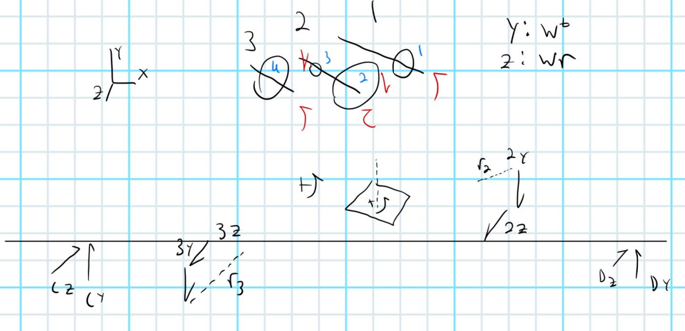
- Shaft Parameters:
  - a = 58mm
  - b = 72.5mm
  - c = 55.5mm
- Critical cross section: Gear 3⁺ (Side closer to shaft center on force application point of gear 3 due to the presence of torque)

  - Diameter at Gear 3⁺: 55mm $=d_{cs}$
  - Critical Point: 4

- Reaction Forces:
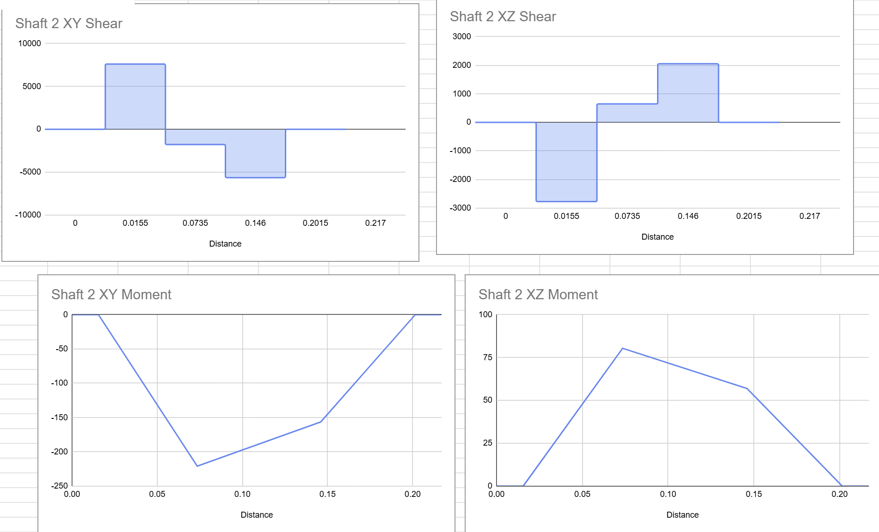
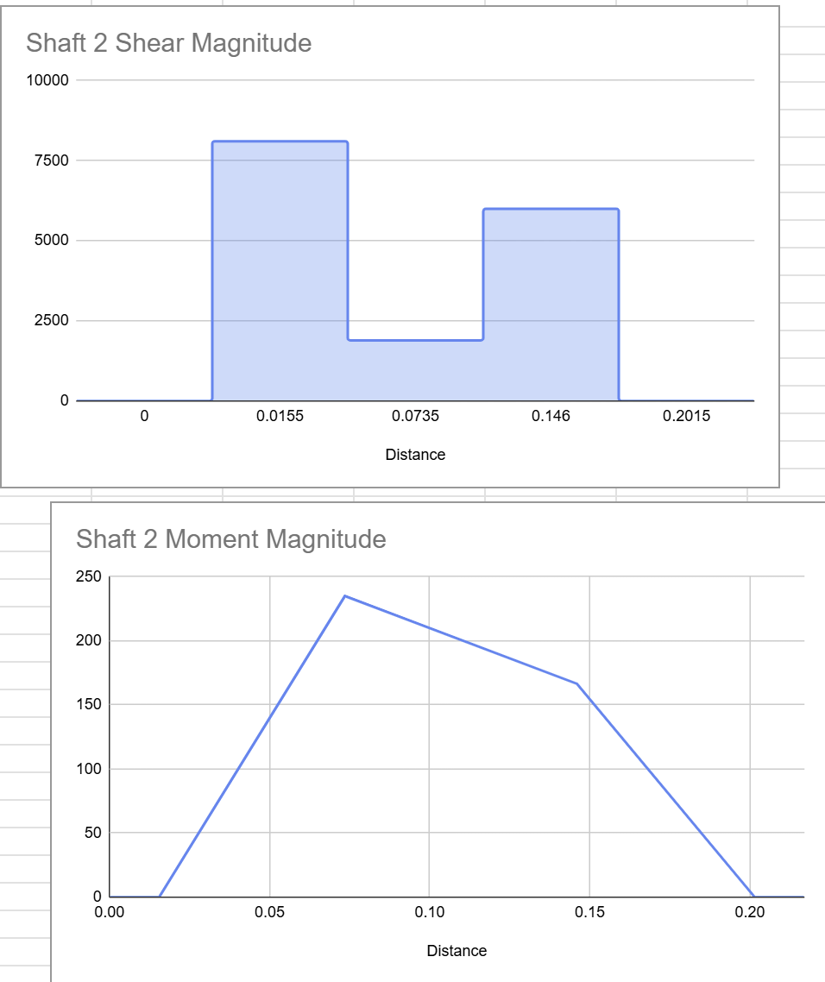
  - $ΣF_{y}=0:C_{y}+D_{y}-W_{t1}-W_{t2}=0$
  - $ΣF_{z}=0:C_{z}+D_{z}-W_{r1}-W_{r2}=0$
- Moments:
  - $ΣM_{y}=0\left(@C\right):{-W}_{r2}\left(a\right)-W_{r3}\left(a+b\right)+D_{y}(a+b+c)=0$
  - $ΣM_{z}=0\left(@C\right):{-W}_{t2}\left(a\right)-W_{t3}\left(a+b\right)+D_{z}(a+b+c)=0$
- Maximum Moments & Shear:
$M_{ymax}=A_{y}\left(a\right)=221 Nm$
$M_{zmax}=A_{z}\left(a\right)=80.4 Nm$
$M_{3+}=\sqrt{M_{ymax}^{2}+M_{zmax}^{2}}=235 Nm$
$V_{3+}=\sqrt{A_{y}^{2}+A_{z}^{2}}=8105 N$

Stress Analysis
- Torsional Shear Stress:
$τ_{T}=\frac{16T_{2}}{πd_{cs}^{3}}=16.5 MPa$
- Bending Stress:
$σ_{b}=\frac{32M_{max}}{πd_{cs}^{3}}=14.4 MPa$
- Von Mises Stresses: Where K_{f} = 1.5, and K_{fs} = 1.3
  - Alternating Von Mises Stress ($σ_{vm-a}$):
$σ_{vm-a}=\sqrt{{\left(K_{f}⋅σ_{b}\right)}^{2}+3{\left(K_{fs}⋅τ_{V}\right)}^{2}}=\sqrt{{\left(1.5⋅14.4\right)}^{2}+3{\left(1.3⋅0\right)}^{2}}=21.6 MPa$
  - Mean Von Mises Stress ($σ_{vm-m}$):
$σ_{vm-m}=\sqrt{3⋅τ_{T}^{2}}=\sqrt{3⋅{16.5}^{2}}=28.6 MPa$
  - Peak Von Mises Stress ($σ_{vm-peak}$):
$σ_{vm-peak}=\sqrt{{{(σ}_{b}^{}+σ_{m}^{})}^{2}+3{\left(τ_{T}+τ_{V}\right)}^{2}}=\sqrt{{14.4}^{2}+3{\left(16.5\right)}^{2}}=32 MPa$

Material Properties
The shaft material selected is AISI 1020 steel, with the following derived properties based on the design conditions:
- Ultimate Tensile Strength ($S_{ut}$):
$S_{ut}=450 MPa$
- Yield Strength ($S_{y}$):
$S_{y}=330 MPa$
- Endurance Limit ($S_{e}$): The true endurance limit is calculated using modifying factors:
$S_{e}=k_{f}k_{s}k_{r}k_{t}k_{m}S_{e}^{′}$
- Where:
  - $k_{f}$ = Stress concentration factor = $1.58{\left(S_{ut}/1000\right)}^{−0.085}=0.94$
  - $k_{s}$ = Size factor = $1.189{\left(1000d_{cs}\right)}^{−0.112}=0.76$
  - $k_{r}$ = Reliability factor = 0.82 (for 99% reliability)
  - $k_{t}$ = Temperature factor = 1 (ambient temperature)
  - $k_{m}$ = Miscellaneous factor = 1 (general use)
- Substituting values:
$S_{e}=0.94×0.80×0.82×1×1×(450×0.5)=132 MPa$

Factors of Safety
- Goodman Factor of Safety ($n_{s}$): The Goodman Factor of Safety is given by:
$n_{s}={\left(\frac{σ_{vm-a}}{S_{e}}+\frac{σ_{vm-m}}{S_{ut}}\right)}^{−1}={\left(\frac{21.6}{132}+\frac{28.6}{450}\right)}^{−1}=4.39$

- Yield Factor of Safety ($n_{y}$): The Yield Factor of Safety is given by the following (ignoring stress concentrations):
$n_{y}={\left(\frac{σ_{vm-a}}{S_{y}}+\frac{σ_{vm-m}}{S_{y}}\right)}^{−1}={\left(\frac{14.4}{330}+\frac{28.6}{330}\right)}^{-1}=7.70$

Shaft System 3:

Key Parameters
Parameter | Symbol | Value | Unit
Speed | $n_{4}$ | 399.94 | rpm
Module | $m$ | 5 | mm
Shaft 1 Torque | T₁ | 212.21 | Nm
Train value | i | 6.75 | -
Number of Teeth | $N_{4}$ | 61 | -
Pitch Circle Diameter | $d_{p4}$ | 305 | mm
Pressure Angle | $ϕ$ | 20 | degrees

Equations and Calculations
- Torque:
$T_{4}=T_{1}⋅i=212.21⋅6.75=1432.60 Nm$
- Tangential Force:
$W_{t}=\frac{{2T}_{4}}{d_{p4}}=\frac{2⋅1432.60}{0.305}=9394.13 N$
- Radial Force:
$W_{r}=W_{t}tan\left(ϕ\right)=9394.13N*tan\left({20}^{∘}\right)=3419.18 N$
- Normal Force:
$W_{n}=\frac{W_{t}}{cos\left(ϕ\right)}=\frac{9394.13N}{cos\left({20}^{∘}\right)}=4106 N$
- Velocity:
$V_{34}=\frac{πn_{4}d_{p4}}{60}=\frac{π×399.94×0.305}{60}=6.39 m/s$
- Operation Hours:
$t=5 years×52 weeks/year×7 days/week×8 hours/day=14560 hours$
- Number of Cycles:
$N_{c4}=\frac{60⋅t⋅n_{4}}{{10}^{6}}=\frac{60×14560×399.94}{{10}^{6}}=349.39 Mc$
- Input Gear Parameters:
Pitch circle diameter: $d_{pi}=780 mm$
Tangential force: ${W^{t}}_{j}=\frac{{2T}_{4}}{d_{pi}}=\frac{2⋅1432.60 Nm}{610mm}=3673.34 N$
Reaction Forces: ${W^{r}}_{j}={W^{t}}_{j}tan(ϕ)=3673.34 N ×tan(20 deg)=1336.99N$

Free Body Diagram and Bending Moments
- Shaft Parameters:
  - a = 58mm
  - b = 72.5mm
  - c = 55.5mm
  - d = 20mm
- Critical cross section: D⁻
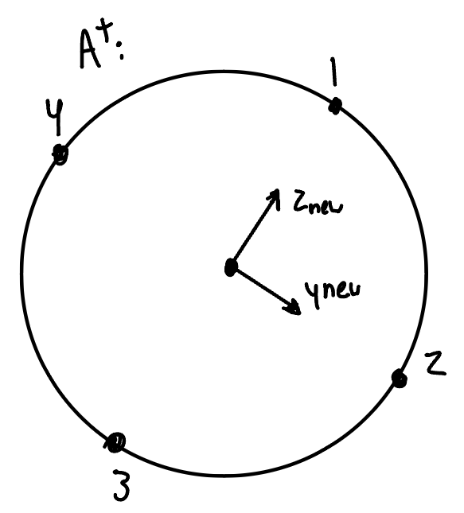
  - Diameter at F⁺: 55mm
  - Critical Point: 3

- Reaction Forces:
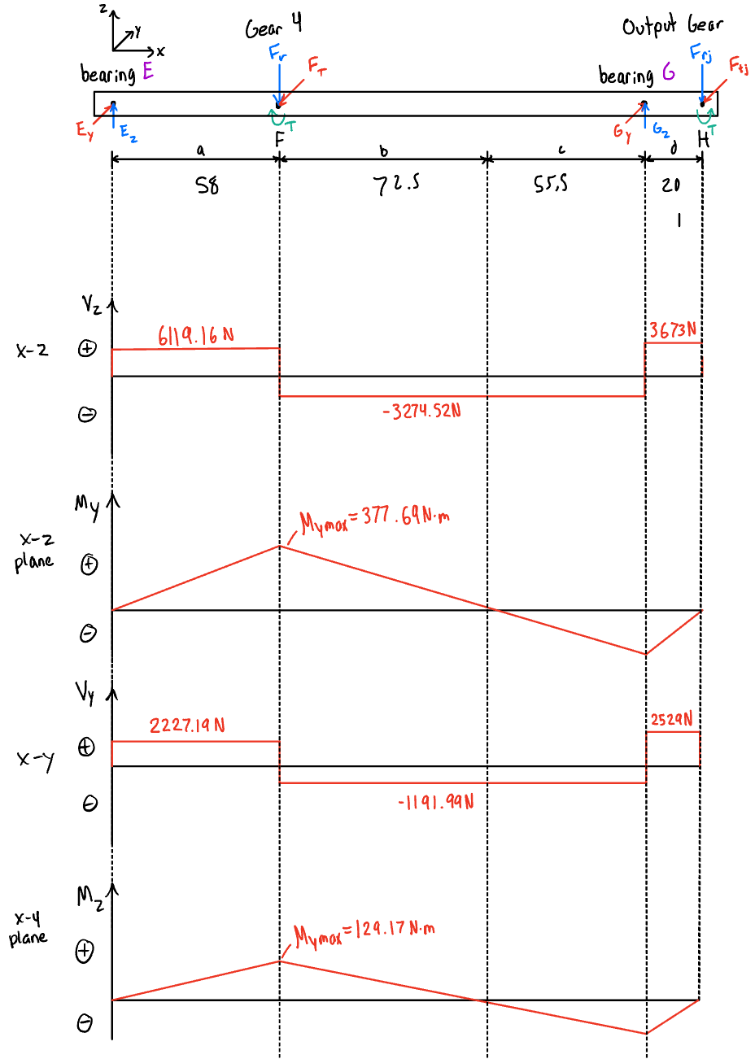
  - $ΣF_{y}=0:E_{y}+G_{y}-W_{t}-W_{tj}=0$
  - $ΣF_{z}=0:A_{z}+B_{z}-W_{r}-W_{rj}=0$
- Moments:
  - $ΣM_{y}=0\left(@E\right):G_{z}\left(a+b+c\right)-W_{r}\left(a\right)-W_{rj}\left(a+b+c+d\right)=0$
  - $ΣM_{z}=0\left(@E\right):G_{y}\left(a+b+c\right)-W_{t}\left(a\right)-W_{tj}\left(a+b+c+d\right)=0$
- Maximum Moments & Shear:
$M_{ymax}=E_{z}\left(a\right)=354.91Nm$
$M_{zmax}=E_{y}\left(a\right)=129.18Nm$
${M_{max}=M}_{F^{+}}=\sqrt{M_{ymax}^{2}+M_{zmax}^{2}}=377.69Nm$
${V_{max}=V}_{F^{+}}=\sqrt{E_{y}^{2}+E_{z}^{2}}=6511.88 N$

Stress Analysis
- Transverse Shear Stress:
$τ_{V}=\frac{16V_{max}}{3πd_{F+}^{2}}=3.65MPa$
- Torsional Shear Stress:
$τ_{T}=\frac{16T_{1}}{πd_{F+}^{3}}=43.85MPa$
- Bending Stress:
$σ_{b}=\frac{32M_{max}}{πd_{F+}^{3}}=23.12 MPa$
- Von Mises Stresses: Where K_{f} = 1.5, and K_{fs} = 1.3
  - Alternating Von Mises Stress ($σ_{vm-a}$):
$σ_{vm-a}=\sqrt{{\left(K_{f}⋅σ_{b}\right)}^{2}+3{\left(K_{fs}⋅τ_{V}\right)}^{2}}=\sqrt{{\left(1.5⋅23.12\right)}^{2}+3{\left(1.3⋅3.65\right)}^{2}}=35.65MPa$
  - Mean Von Mises Stress ($σ_{vm-m}$):
$σ_{vm-m}=\sqrt{3⋅τ_{T}^{2}}=\sqrt{3⋅{43.85}^{2}}=75.96MPa$
  - Peak Von Mises Stress ($σ_{vm-peak}$):
$σ_{vm-peak}=\sqrt{σ_{b}^{2}+3{\left(τ_{T}+τ_{V}\right)}^{2}}=\sqrt{{23.12}^{2}+3{\left(43.85+3.65\right)}^{2}}=85.47MPa$

Material Properties
The shaft material selected is AISI 1020 steel, with the following derived properties based on the design conditions:
- Ultimate Tensile Strength ($S_{ut}$):
$S_{ut}=450 MPa$
- Yield Strength ($S_{y}$):
$S_{y}=330 MPa$
- Endurance Limit ($S_{e}$): The true endurance limit is calculated using modifying factors:
$S_{e}=k_{f}k_{s}k_{r}k_{t}k_{m}S_{e}^{′}$
- Where:
  - $k_{f}$ = Stress concentration factor = $1.58{\left(S_{ut}/1000\right)}^{−0.085}=0.94$
  - $k_{s}$ = Size factor = $1.189{\left(1000d_{cs}\right)}^{−0.112}=0.76$
  - $k_{r}$ = Reliability factor = 0.82 (for 99% reliability)
  - $k_{t}$ = Temperature factor = 1 (ambient temperature)
  - $k_{m}$ = Miscellaneous factor = 1 (general use)
- Substituting values:
$S_{e}=0.94×0.76×0.82×1×1×450=132 MPa$

Factors of Safety
- Goodman Factor of Safety ($n_{s}$): The Goodman Factor of Safety is given by:
$n_{s}={\left(\frac{σ_{vm-a}}{S_{e}}+\frac{σ_{vm-m}}{S_{ut}}\right)}^{−1}={\left(\frac{35.65}{132}+\frac{75.96}{450}\right)}^{−1}=2.27$

- Yield Factor of Safety ($n_{y}$): The Yield Factor of Safety is given by:
$n_{y}=\frac{S_{y}}{σ_{vm-peak}}=\frac{330}{85.47}=3.86$

Appendix 2 - Gear Analysis

Shaft 1 Gear Analysis:

Key Parameters
Parameter | Symbol | Equation | Value | Unit
Train Value | $i$ | $i=6.75$ | 6.75 | -
Input Power | $H$ | $H=60,000$ | 60,000 | W
Torque | $T_{1}$ | $T_{1}=\frac{60H}{2πn_{1}}$ | 212.21 | Nm
Number of Teeth (Gear 1) | $N_{1}$ | $N_{1}=22$ | 22 | -
Addendum | $a$ | $a=m$ | 5 | mm
Dedendum | $b$ | $b=1.25m$ | 6 | mm
Tooth Height | $h$ | $h=a+b$ | 11 | mm
Clearance | $c$ | $c=b−a$ | 1 | mm
Circular Pitch | $p_{c}$ | $p_{c}=πm$ | 16 | mm
Base Pitch | $p_{b}$ | $p_{b}=πmcos\left(ϕ\right)$ | 15 | mm
Base Width | $b_{w}$ | $b_{w}=13m$ | 65 | mm
Tooth Thickness | $t$ | $t=\frac{p_{c}}{2}$ | 8 | mm
Pitch Circle Diameter | $d_{p1}$ | $d_{p1}=N_{1}⋅m$ | 110 | mm
Outside Circle Diameter | $d_{o1}$ | $d_{o1}=d_{p1}+2a$ | 120 | mm
Base Circle Diameter | $d_{b1}$ | $d_{b1}=d_{p1}cos\left(ϕ\right)$ | 103 | mm
Root Circle Diameter | $d_{r1}$ | $d_{r1}=d_{p1}−2b$ | 97.5 | mm
Tangential Force | $W_{t}$ | $W_{t}=\frac{T_{1}}{d_{p1}/2}$ | 3858 | N
Velocity | $V_{12}$ | $V_{12}=\frac{πn_{1}d_{p1}}{60}$ | 15.6 | m/s
Operation Hours | $t$ | $t=5 years×52×7×8$ | 14,560 | hrs
Number of Cycles | $N_{c1}$ | $N_{c1}=\frac{60tn_{1}}{{10}^{6}}$ | 2358.72 | Mc

Equations and Calculations
- Radial Force ($W_{r}$): The radial force is calculated using the pressure angle:
$W_{r}=W_{t}⋅tan\left(ϕ\right)$
- Substituting values:
$W_{r}=3858⋅tan\left({20}^{∘}\right)=1404 N$
- Normal Force ($W_{n}$): The normal force is derived from the tangential force:
$W_{n}=\frac{W_{t}}{cos\left(ϕ\right)}$
- Substituting values:
$W_{n}=\frac{3858}{cos\left({20}^{∘}\right)}=4106 N$

Stress Analysis
- Bending Stress ($σ_{pb}$): The bending stress is calculated using:
$σ_{pb}=\frac{W_{t}⋅k_{b}}{b_{w}⋅m⋅Y_{j}}$
- Where:
  - Bending geometry factor: $Y_{j}=0.33$ (from Figure 5-50 in chapter 5 e-book)
  - Load factor:
$k_{b}=K_{b}⋅K_{i}⋅K_{a}⋅K_{m}⋅K_{v}$
    - $K_{b}=1$, $K_{i}=1$, $K_{a}=1$, $K_{m}=1.2$, $K_{v}={\frac{59.7+\sqrt{200V_{12}}}{59.7}}^{0.825}$
Substituting Velocity $V_{12}=15.6 m/s$ :
$K_{v}={\left(\frac{59.7+\sqrt{200⋅15.6}}{59.7}\right)}^{0.825}=1.72$
$k_{b}=1⋅1⋅1⋅1.2⋅1.72=2.07$
- Substituting into the stress equation:
$σ_{pb}=\frac{3858⋅2.07}{65⋅5⋅0.33}=74 MPa$
- Contact Stress ($σ_{pc}$): The contact stress is given by:
$σ_{pc}=K_{e}⋅\sqrt{\frac{W_{t}⋅k_{c}}{b_{w}⋅d_{p1}⋅I}}$
- Where:
$K_{e}=\sqrt{\frac{1−ν_{1}^{2}}{E_{1}}+\frac{1−ν_{2}^{2}}{E_{2}}}$
- With material properties:
  - $E_{1}=E_{2}=2.07×{10}^{11} Pa$, $ν_{1}=ν_{2}=0.3$
$K_{e}=\sqrt{\frac{1−{0.3}^{2}}{2.07×{10}^{11}}+\frac{1−{0.3}^{2}}{2.07×{10}^{11}}}=473675$
- Geometry factor:
$I=π⋅cos\left(ϕ\right)⋅sin\left(ϕ\right)\left(1+\frac{d_{p1}}{d_{p2}}\right)$
- Substituting:
$I=π⋅cos\left({20}^{∘}\right)⋅sin\left({20}^{∘}\right)⋅\left(1+\frac{110}{280}\right)=0.72$
- Load factor:
$k_{c}=2.07$
- Substituting into the contact stress equation:
$σ_{pc}=473675⋅\sqrt{\frac{3858⋅2.07}{65⋅110⋅0.72}}=587 MPa$

Material Properties and Allowable Stresses
- Hardness:
$HB_{p}=578$
- Allowable Bending Stress (No Factors):
$S_{pb}=\left(0.703⋅HB_{p}+113\right)⋅{10}^{6}=519 MPa$
- Allowable Contact Stress (No Factors):
$S_{pc}=\left(2.41⋅HB_{p}+237\right)⋅{10}^{6}=1629 MPa$
- Geometry Factor for Bending: Equation determined from Figure 5-46 in e-book.
$Y_{np}=1.6831⋅\left(N_{c1}^{−0.0323}\right)=0.84$
- Geometry Factor for Contact: Equation determined from Figure 5-46 in e-book.
$Z_{np}=2.466⋅\left(N_{c1}^{−0.056}\right)=0.74$
- Load Sharing Factor:
$C_{hg}=1+((8.89⋅{10}^{-3})⋅\frac{HB_{P}}{{HG}_{G}}-8.29⋅{10}^{-3})(\frac{N_{G}}{N_{P}}-1)=1.005$
- Allowable Bending Stress (With Factors):
$S_{all,bp}=\frac{S_{pb}⋅Y_{np}}{K_{t}⋅K_{r}}=\frac{519⋅0.84}{1⋅1}=435 MPa$

- Allowable Contact Stress (With Factors):
$S_{all,cp}=\frac{S_{pc}⋅Z_{np}⋅C_{hp}}{K_{t}⋅K_{r}}=\frac{1629⋅0.74⋅1}{1⋅1}=1200 MPa$

Factors of Safety
- Bending Stress Factor of Safety ($n_{bp}$):
$n_{bp}=\frac{S_{all, bp}}{σ_{pb}}$$\frac{435}{74}=5.85$

- Contact Stress Factor of Safety ($n_{cp}$):
$n_{cp}=\frac{S_{all, cp}}{σ_{pc}}\frac{1200}{587}=2.04$

Shaft 2 Gear Analysis:

Key Parameters
Parameter | Symbol | Equation | Value | Unit
Train Value | $i$ | $i=6.75$ | 6.75 | -
Input Power | $H$ | $H=60,000$ | 60,000 | W
Torque | $T_{2}$ | $T_{2}=\frac{60H}{2πn_{2}}$ | 540.16 | Nm
Number of Teeth (Gear 2) | $N_{2}$ | $N_{2}=56$ | 56 | -
Number of Teeth (Gear 3) | $N_{3}$ | $N_{3}=23$ | 23 | -
Addendum | $a$ | $a=m$ | 5 | mm
Dedendum | $b$ | $b=1.25m$ | 6 | mm
Tooth Height | $h$ | $h=a+b$ | 11 | mm
Clearance | $c$ | $c=b−a$ | 1 | mm
Circular Pitch | $p_{c}$ | $p_{c}=πm$ | 16 | mm
Base Pitch | $p_{b}$ | $p_{b}=πmcos\left(ϕ\right)$ | 15 | mm
Base Width (Gear 2) | $b_{w}$ | $b_{w}=12m$ | 60 | mm
Base Width (Gear 3) | $b_{w}$ | $b_{w}=13m$ | 65 | mm
Tooth Thickness | $t$ | $t=\frac{p_{c}}{2}$ | 8 | mm
Pitch Circle Diameter (Gear 2) | $d_{p2}$ | $d_{p2}=N_{2}⋅m$ | 280 | mm
Outside Circle Diameter (Gear 2) | $d_{o2}$ | $d_{o2}=d_{p2}+2a$ | 290 | mm
Base Circle Diameter (Gear 2) | $d_{b2}$ | $d_{b2}=d_{p2}cos\left(ϕ\right)$ | 263 | mm
Root Circle Diameter (Gear 2) | $d_{r2}$ | $d_{r2}=d_{p2}−2b$ | 267.5 | mm
Tangential Force (Gear 2) | $W_{t}$ | $W_{t}=\frac{T_{1}}{d_{p2}/2}$ | 3858 | N
Velocity (Gear 2) | $V_{12}$ | $V_{12}=\frac{πn_{2}d_{p2}}{60}$ | 15.6 | m/s
Pitch Circle Diameter (Gear 3) | $d_{p3}$ | $d_{p3}=N_{3}⋅m$ | 115 | mm
Outside Circle Diameter (Gear 3) | $d_{o3}$ | $d_{o3}=d_{p3}+2a$ | 125 | mm
Base Circle Diameter (Gear 3) | $d_{b3}$ | $d_{b3}=d_{p3}cos\left(ϕ\right)$ | 108 | mm
Root Circle Diameter (Gear 3) | $d_{r3}$ | $d_{r3}=d_{p3}−2b$ | 102.5 | mm
Tangential Force (Gear 3) | $W_{t}$ | $W_{t}=\frac{T_{1}}{d_{p3}/2}$ | 9394 | N
Velocity (Gear 3) | $V_{34}$ | $V_{34}=\frac{πn_{3}d_{p3}}{60}$ | 6.39 | m/s
Operation Hours | $t$ | $t=5 years×52×7×8$ | 14,560 | hrs
Number of Cycles | $N_{c}$ | $N_{c2}=N_{c3}=\frac{60tn_{2}}{{10}^{6}}$ | 926.64 | Mc

Equations and Calculations
- Radial Force ($W_{r}$): The radial force is calculated using the pressure angle:
$W_{r}=W_{t}⋅tan\left(ϕ\right)$
- Substituting values:
$W_{r2}=3858⋅tan\left({20}^{∘}\right)=1404 N$
$W_{r3}=9394⋅tan\left({20}^{∘}\right)=3419 N$
- Normal Force ($W_{n}$): The normal force is derived from the tangential force:
$W_{n}=\frac{W_{t}}{cos\left(ϕ\right)}$
- Substituting values:
$W_{n2}=\frac{3858}{cos\left({20}^{∘}\right)}=4106 N$
$W_{n3}=\frac{9394}{cos\left({20}^{∘}\right)}=9997 N$

Stress Analysis (Gear 2)
- Bending Stress ($σ_{pb}$): The bending stress is calculated using:
$σ_{pb}=\frac{W_{t}⋅k_{b}}{b_{w}⋅m⋅Y_{j}}$
- Where:
  - Bending geometry factor: $Y_{j}=0.41$ (from Figure 5-50 in chapter 5 e-book)
  - Load factor:
$k_{b}=K_{b}⋅K_{i}⋅K_{a}⋅K_{m}⋅K_{v}$
    - $K_{b}=1$, $K_{i}=1$, $K_{a}=1$, $K_{m}=1.15$, $K_{v}={\frac{59.7+(200V_{12})^{0.5}}{59.7}}^{0.825}$
Substituting Velocity $V_{12}=15.6 m/s$ :
$K_{v}={\left(\frac{59.7+\sqrt{200⋅15.6}}{59.7}\right)}^{0.825}=1.72$
$k_{b}=1⋅1⋅1⋅1.2⋅1.72=1.98$
- Substituting into the stress equation:
$σ_{pb}=\frac{3858⋅1.98}{60E-3⋅5E-3⋅0.41}=62 MPa$
- Contact Stress ($σ_{pc}$): The contact stress is given by:
$σ_{pc}=K_{e}⋅\sqrt{\frac{W_{t}⋅k_{c}}{b_{w}⋅d_{p2}⋅I}}$
- Where:
$K_{e}=\sqrt{\frac{1−ν_{1}^{2}}{E_{1}}+\frac{1−ν_{2}^{2}}{E_{2}}}$
- With material properties:
  - $E_{1}=E_{2}=2.07×{10}^{11} Pa$, $ν_{1}=ν_{2}=0.3$
$K_{e}=\sqrt{\frac{1−{0.3}^{2}}{2.07×{10}^{11}}+\frac{1−{0.3}^{2}}{2.07×{10}^{11}}}=473675$
- Geometry factor:
$I=π⋅cos\left(ϕ\right)⋅sin\left(ϕ\right)\left(1+\frac{d_{p1}}{d_{p2}}\right)$
- Substituting:
$I=π⋅cos\left({20}^{∘}\right)⋅sin\left({20}^{∘}\right)⋅\left(1+\frac{110}{280}\right)=0.72$
- Load factor:
$k_{c}=1.98$
- Substituting into the contact stress equation:
$σ_{pc}=473675⋅\sqrt{\frac{3858⋅1.98}{60E-3⋅110E-3⋅0.41}}=599 MPa$

Stress Analysis (Gear 3)
- Bending Stress ($σ_{pb}$): The bending stress is calculated using:
$σ_{pb}=\frac{W_{t}⋅k_{b}}{b_{w}⋅m⋅Y_{j}}$
- Where:
  - Bending geometry factor: $Y_{j}=0.35$ (from Figure 5-50 in chapter 5 e-book)
  - Load factor:
$k_{b}=K_{b}⋅K_{i}⋅K_{a}⋅K_{m}⋅K_{v}$
    - $K_{b}=1$, $K_{i}=1$, $K_{a}=1$, $K_{m}=1.15$, $K_{v}={\frac{59.7+(200V_{34})^{0.5}}{59.7}}^{0.825}$
Substituting Velocity $V_{34}=6.39 m/s$ :
$K_{v}={\left(\frac{59.7+\sqrt{200⋅6.39}}{59.7}\right)}^{0.825}=1.47$
$k_{b}=1⋅1⋅1⋅1.15⋅1.47=1.69$
- Substituting into the stress equation:
$σ_{pb}=\frac{9394⋅1.47}{65E-3⋅5E-3⋅0.35}=140 MPa$
- Contact Stress ($σ_{pc}$): The contact stress is given by:
$σ_{pc}=K_{e}⋅\sqrt{\frac{W_{t}⋅k_{c}}{b_{w}⋅d_{p3}⋅I}}$
- Where:
$K_{e}=\sqrt{\frac{1−ν_{1}^{2}}{E_{1}}+\frac{1−ν_{2}^{2}}{E_{2}}}$
- With material properties:
  - $E_{1}=E_{2}=2.07×{10}^{11} Pa$, $ν_{1}=ν_{2}=0.3$
$K_{e}=\sqrt{\frac{1−{0.3}^{2}}{2.07×{10}^{11}}+\frac{1−{0.3}^{2}}{2.07×{10}^{11}}}=473675$
- Geometry factor:
$I=π⋅cos\left(ϕ\right)⋅sin\left(ϕ\right)\left(1+\frac{d_{p3}}{d_{p4}}\right)$
- Substituting:
$I=π⋅cos\left({20}^{∘}\right)⋅sin\left({20}^{∘}\right)⋅\left(1+\frac{115}{305}\right)=0.73$
- Load factor:
$k_{c}=1.69$
- Substituting into the contact stress equation:
$σ_{pc}=473675⋅\sqrt{\frac{9394⋅1.69}{65E-3⋅115E-3⋅0.35}}=807 MPa$

Material Properties and Allowable Stresses (Gear 2)
- Hardness:
$HB_{p}=450$
- Allowable Bending Stress (No Factors):
$S_{pb}=\left(0.533⋅HB_{p}+88.3\right)⋅{10}^{6}=328 MPa$
- Allowable Contact Stress (No Factors):
$S_{pc}=\left(2.22⋅HB_{p}+200\right)⋅{10}^{6}=1199 MPa$
- Geometry Factor for Bending: Equation determined from Figure 5-46 in e-book.
$Y_{np}=1.6831⋅\left(N_{c2}^{−0.0323}\right)=0.86$
- Geometry Factor for Contact: Equation determined from Figure 5-46 in e-book.
$Z_{np}=2.466⋅\left(N_{c2}^{−0.056}\right)=0.78$
- Load Sharing Factor:
$C_{hg}=1+((8.89⋅{10}^{-3})⋅\frac{HB_{P}}{{HG}_{G}}-8.29⋅{10}^{-3})(\frac{N_{G}}{N_{P}}-1)=0.998$
- Allowable Bending Stress (With Factors):
$S_{all,bp}=\frac{S_{pb}⋅Y_{np}}{K_{t}⋅K_{r}}=\frac{328⋅0.86}{1⋅1}=283 MPa$

- Allowable Contact Stress (With Factors):
$S_{all,cp}=\frac{S_{pc}⋅Z_{np}⋅C_{hp}}{K_{t}⋅K_{r}}=\frac{1199⋅0.78⋅0.998}{1⋅1}=928 MPa$

Factors of Safety
- Bending Stress Factor of Safety ($n_{bp}$):
$n_{bp}=\frac{S_{all, bp}}{σ_{pb}}=\frac{283}{62.2}=4.56$

- Contact Stress Factor of Safety ($n_{cp}$):
$n_{cp}=\frac{S_{all, cp}}{σ_{pc}}\frac{1199}{599}=1.55$

Material Properties and Allowable Stresses (Gear 3)
- Hardness:
$HB_{p}=578$
- Allowable Bending Stress (No Factors):
$S_{pb}=\left(0.533⋅HB_{p}+88.3\right)⋅{10}^{6}=396 MPa$
- Allowable Contact Stress (No Factors):
$S_{pc}=\left(2.22⋅HB_{p}+200\right)⋅{10}^{6}=1483 MPa$
- Geometry Factor for Bending: Equation determined from Figure 5-46 in e-book.
$Y_{np}=1.6831⋅\left(N_{c3}^{−0.0323}\right)=0.86$
- Geometry Factor for Contact: Equation determined from Figure 5-46 in e-book.
$Z_{np}=2.466⋅\left(N_{c3}^{−0.056}\right)=0.78$
- Load Sharing Factor:
$C_{hg}=1+((8.89⋅{10}^{-3})⋅\frac{HB_{P}}{{HG}_{G}}-8.29⋅{10}^{-3})(\frac{N_{G}}{N_{P}}-1)=1.005$
- Allowable Bending Stress (With Factors):
$S_{all,bp}=\frac{S_{pb}⋅Y_{np}}{K_{t}⋅K_{r}}=\frac{396⋅0.86}{1⋅1}=342 MPa$

- Allowable Contact Stress (With Factors):
$S_{all,cp}=\frac{S_{pc}⋅Z_{np}⋅C_{hp}}{K_{t}⋅K_{r}}=\frac{1483⋅0.78⋅1.005}{1⋅1}=1157 MPa$

Factors of Safety
- Bending Stress Factor of Safety ($n_{bp}$):
$n_{bp}=\frac{S_{all, bp}}{σ_{pb}}=\frac{342}{140}=2.45$

- Contact Stress Factor of Safety ($n_{cp}$):
$n_{cp}=\frac{S_{all, cp}}{σ_{pc}}\frac{1157}{807}=1.43$

Shaft 3 Gear Analysis:

Key Parameters
Parameter | Symbol | Equation | Value | Unit
Train Value | $i$ | $i=6.75$ | 6.75 | -
Input Power | $H$ | $H=60,000$ | 60,000 | W
Torque | $T_{4}$ | $T_{4}=T_{1}⋅i$ | 1432.60 | Nm
Number of Teeth (Gear 1) | $N_{4}$ | # of teeth | 61 | -
Addendum | $a$ | $a=m$ | 5 | mm
Dedendum | $b$ | $b=1.25m$ | 6 | mm
Tooth Height | $h$ | $h=a+b$ | 11 | mm
Clearance | $c$ | $c=b−a$ | 1 | mm
Circular Pitch | $p_{c}$ | $p_{c}=πm$ | 16 | mm
Base Pitch | $p_{b}$ | $p_{b}=πmcos\left(ϕ\right)$ | 15 | mm
Base Width | $b_{w}$ | $b_{w}=13m$ | 65 | mm
Tooth Thickness | $t$ | $t=8$ | 8 | mm
Pitch Circle Diameter | $d_{p4}$ | $d_{p4}=N_{4}⋅m$ | 305 | mm
Outside Circle Diameter | $d_{o4}$ | $d_{o4}=d_{p4}+2a$ | 315 | mm
Base Circle Diameter | $d_{b4}$ | $d_{b4}=d_{p4}cos\left(ϕ\right)$ | 287 | mm
Root Circle Diameter | $d_{r4}$ | $d_{r4}=d_{p4}−2b$ | 292.5 | mm
Tangential Force | $W_{t4}$ | $W_{t4}=\frac{T_{4}}{d_{p4}/2}$ | 9394.13 | N
Velocity | $V_{34}$ | $V_{34}=\frac{πn_{4}d_{p4}}{60}$ | 6.39 | m/s
Operation Hours | $t$ | $t=5 years×52×7×8$ | 14,560 | hrs
Number of Cycles | $N_{c4}$ | $N_{c4}=\frac{60tn_{4}}{{10}^{6}}$ | 349.39 | Mc

Equations and Calculations
- Radial Force ($W_{r}$): The radial force is calculated using the pressure angle:
$W_{r}=W_{t}⋅tan\left(ϕ\right)$
- Substituting values:
$W_{r}=9394.18⋅tan\left({20}^{∘}\right)=3419.18N$
- Normal Force ($W_{n}$): The normal force is derived from the tangential force:
$W_{n}=\frac{W_{t}}{cos\left(ϕ\right)}$
- Substituting values:
$W_{n}=\frac{9394.18}{cos\left({20}^{∘}\right)}=9997.02 N$

Stress Analysis
- Bending Stress ($σ_{pb}$): The bending stress is calculated using:
$σ_{gb}=\frac{W_{t4}⋅k_{b}}{b_{w}⋅m⋅Y_{j}}$
- Where:
  - Bending geometry factor: $Y_{j}=0.41$ (from Figure 5-50 in e-book)
  - Load factor:
$k_{b}=K_{b}⋅K_{i}⋅K_{a}⋅K_{m}⋅K_{v}$
    - $K_{b}=1$, $K_{i}=1$, $K_{a}=1$, $K_{m}=1.2$, $K_{v}={\frac{59.7+(200V_{34})^{0.5}}{59.7}}^{0.825}$
Substituting Velocity $V_{12}=6.39 m/s$ :
$K_{v}={\left(\frac{59.7+\sqrt{200⋅6.39}}{59.7}\right)}^{0.825}=1.47$
$k_{b}=1⋅1⋅1⋅1.2⋅1.47=1.77$
- Substituting into the stress equation:
$σ_{pb}=\frac{9394.13⋅1.77}{60⋅5⋅0.41}=135.03 MPa$
- Contact Stress ($σ_{pc}$): The contact stress is given by:
$σ_{gc}=K_{e}⋅\sqrt{\frac{W_{t}⋅k_{c}}{b_{w}⋅d_{p1}⋅I}}$
- Where:
$K_{e}=\sqrt{\frac{1−ν_{1}^{2}}{E_{1}}+\frac{1−ν_{2}^{2}}{E_{2}}}$
- With material properties:
  - $E_{1}=E_{2}=2.07×{10}^{11} Pa$, $ν_{1}=ν_{2}=0.3$
$K_{e}=\sqrt{\frac{1−{0.3}^{2}}{2.07×{10}^{11}}+\frac{1−{0.3}^{2}}{2.07×{10}^{11}}}=473675$
- Geometry factor:
$I=π⋅cos\left(ϕ\right)⋅sin\left(ϕ\right)\left(1+\frac{d_{p1}}{d_{p2}}\right)$
- Substituting:
$I=π⋅cos\left({20}^{∘}\right)⋅sin\left({20}^{∘}\right)⋅\left(1+\frac{110}{280}\right)=0.72$
- Load factor:
$k_{c}=2.07$
- Substituting into the contact stress equation:
$σ_{pc}=473675⋅\sqrt{\frac{3858⋅2.07}{65⋅110⋅0.72}}=858.24 MPa$

Material Properties and Allowable Stresses
Hardness:
$HB_{g}=450$
Allowable Bending Stress (No Factors):
$S_{gb}=\left(0.533⋅HB_{g}+88.3\right)⋅{10}^{6}=328 .15MPa$
Allowable Contact Stress (No Factors):
$S_{gc}=\left(2.22⋅HB_{g}+200\right)⋅{10}^{6}=1199 MPa$
Geometry Factor for Bending: Equation determined from Figure 5-46 in e-book.
$Y_{ng}=1.6831⋅\left(N_{c4}^{−0.0323}\right)=0.89$
Geometry Factor for Contact: Equation determined from Figure 5-46 in e-book.
$Z_{ng}=2.466⋅\left(N_{c4}^{−0.056}\right)=0.82$
Allowable Bending Stress (With Factors):
$S_{all,bg}=\frac{S_{pb}⋅Y_{np}}{K_{t}⋅K_{r}}=\frac{519⋅0.84}{1⋅1}=292.57 MPa$
Allowable Contact Stress (With Factors):
$S_{all,cg}=\frac{S_{pc}⋅Z_{np}⋅C_{hp}}{K_{t}⋅K_{r}}=\frac{1629⋅0.74⋅1}{1⋅1}=987.70 MPa$

Factors of Safety
- Bending Stress Factor of Safety ($n_{bp}$):
$n_{bp}=\frac{S_{all, bp}}{σ_{pb}}=\frac{292.57}{135.03}=2.16$

- Contact Stress Factor of Safety ($n_{cp}$):
$n_{cp}=\frac{S_{all, cp}}{σ_{pc}}=\frac{987.70}{858.24}=1.15$

Appendix 3 - Bearing Selection
Bearing Label Schematic:
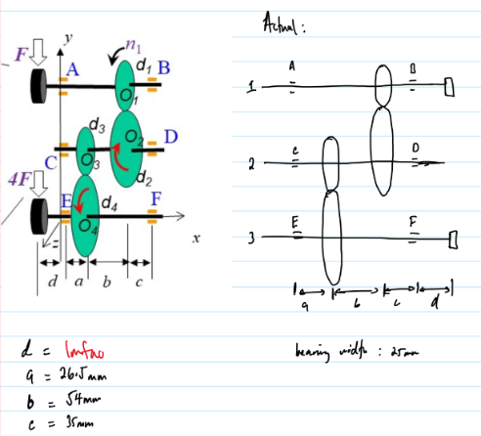

Shaft 1 Bearing Selection:

Key Parameters
Parameter | Symbol | Equation | Value | Unit
Radial Force at A | $F_{rA}$ | $F_{rA}=\sqrt{A_{y}^{2}+A_{z}^{2}}$ | 1171 | N
Radial Force at B | $F_{rB}$ | $F_{rB}=\sqrt{B_{y}^{2}+B_{z}^{2}}$ | 3514 | N
Life in Millions of Cycles | $L_{10}$ | From shaft analysis | 2358.72 | Mc
Application Factor | $A_{p}$ | $A_{p}=1$ (No additional load factors) | 1 | -
Bearing Type | - | SKF Deep Groove Ball Bearing | - | -

Bearing Selection
- For Bearing at B:
  - Load on the bearing:
$P=A_{p}⋅F_{rB}=1⋅3514=3514 N$
  - Dynamic load capacity:
$C=P⋅L_{10}^{1/m}$
  - Substituting $m=3$:
$C=3514⋅{2358.72}^{1/3}=46780 N$
  - Selected Bearing:
$Bearing 6309: d_{b}=45 mm, OD=100 mm, C=52700 N, w=25 mm$
- For Bearing at A:
  - Load on the bearing:
$P=A_{p}⋅F_{rA}=1⋅1171=1171 N$
  - Dynamic load capacity:
$C=P⋅L_{10}^{1/m}$
  - Substituting $m=3$:
$C=1171⋅{2358.72}^{1/3}=15583 N$
  - Selected Bearing:
$Bearing 6304: d_{b}=20 mm, OD=52 mm, C=15000 N, w=15 mm$

Final Bearing Selection
Bearing 6309: (same for both): $d_{b}=45 mm, OD=100 mm, C=52700 N, w=25 mm$
No bearing changes are required during the five year service period.

Shaft 2 Bearing Selection:

Key Parameters
Parameter | Symbol | Equation | Value | Unit
Radial Force at C | $F_{rA}$ | $F_{rA}=\sqrt{A_{y}^{2}+A_{z}^{2}}$ | 8105 | N
Radial Force at D | $F_{rB}$ | $F_{rB}=\sqrt{B_{y}^{2}+B_{z}^{2}}$ | 5998 | N
Life in Millions of Cycles | $L_{10}$ | From shaft analysis | 926.64 | Mc
Application Factor | $A_{p}$ | $A_{p}=1$ (No additional load factors) | 1 | -
Bearing Type | - | SKF Deep Groove Ball Bearing | - | -

Bearing Selection
- For Bearing at C:
  - Load on the bearing:
$P=A_{p}⋅F_{rB}=1⋅8105=8105 N$
  - Dynamic load capacity:
$C=P⋅L_{10}^{1/m}$
  - Substituting $m=3$:
$C=8105⋅{926.64}^{1/3}=79016 N$
  - Selected Bearing:
$Bearing 6410: d_{b}=55 mm, OD=130 mm, C=87100 N, w=31 mm$
- For Bearing at D:
  - Load on the bearing:
$P=A_{p}⋅F_{rA}=1⋅5998=5998 N$
  - Dynamic load capacity:
$C=P⋅L_{10}^{1/m}$
  - Substituting $m=3$:
$C=5998⋅926.65=58477 N$
  - Selected Bearing:
$Bearing 6310: d_{b}=55 mm, OD=110 mm, C=61800 N, w=27 mm$

Final Bearing Selection
Bearing 6410: (same for both): $d_{b}=55 mm, OD=130 mm, C=87100 N, w=31 mm$
No bearing changes are required during the five year service period.

Shaft 3 Bearing Selection:

Key Parameters
Parameter | Symbol | Equation | Value | Unit
Radial Force at E | $F_{rA}$ | $F_{rA}=\sqrt{A_{y}^{2}+A_{z}^{2}}$ | 6511.88 | N
Radial Force at F | $F_{rB}$ | $F_{rB}=\sqrt{B_{y}^{2}+B_{z}^{2}}$ | 7394.23 | N
Life in Millions of Cycles | $L_{10}$ | From shaft analysis | 349.39 | Mc
Application Factor | $A_{p}$ | $A_{p}=1$ (No additional load factors) | 1 | -
Bearing Type | - | SKF Deep Groove Ball Bearing | - | -

Bearing Selection
- For Bearing at E:
  - Load on the bearing:
$P=A_{p}⋅F_{rB}=1⋅6511.88=6511.88 N$
  - Dynamic load capacity:
$C=P⋅L_{10}^{1/m}$
  - Substituting $m=3$:
$C=6511.88⋅{349.39}^{1/3}=45864.43N$
  - Selected Bearing:
$Bearing 6209: d_{b}=45 mm, OD=85 mm, C=33200 N, w=19 mm$
- For Bearing at G:
  - Load on the bearing:
$P=A_{p}⋅F_{rA}=1⋅7394.23=7394.23 N$
  - Dynamic load capacity:
$C=P⋅L_{10}^{1/m}$
  - Substituting $m=3$:
$C=7394.23⋅{349.39}^{1/3}=52079.02 N$
  - Selected Bearing:
$Bearing 6309: d_{b}=45 mm, OD=100 mm, C=52700 N, w=25 mm$

Final Bearing Selection
Bearing 6309: (same for both): $d_{b}=45 mm, OD=100 mm, C=52700 N, w=25 mm$
No bearing changes are required during the five year service period.

